
Senate Resolution No. 2025/2026-055
Approval of the Wall Street Journal & ASUC Contract

Primary Sponsor
Isha Chander (ASUC Executive Vice President)

WHEREAS, the preamble of the ASUC Constitution mandates that the Association “promote the welfare of students [and] participate in the formation and the improvement of educational programs ”; and,

WHEREAS, pursuant to Section 1-B, Article III-A of the Constitution, the Senate has final authority to enter into and authorize contracts and other legal instruments as the governing body of the Association; and,

WHEREAS, the Associated Students of the University of California encourages enhancement of academic knowledge through a partnership with The Wall Street Journal; and,

WHEREAS, the ASUC first signed a contract with the Wall Street Journal in the 2019/2020 term and renewed the contract in 2022, and that contract is up for renewal again; and,

THEREFORE IT BE RESOLVED, that the Senate approves entering into a 4-year contract renewal with the Wall Street Journal (Appendix A) and will finance the contract through the ASUC Commercial Activities & Student Services Agreement (CASSA) fund, for the following amounts per yer
- $23,306.49 in Year 1
- $23,763.48 in Year 2
- $24,220.47 in Year 3
- $24,677.46 in Year 4; and,

THEREFORE IT BE FURTHER RESOLVED, that the ASUC will commit to finding partners in the future to share the cost of providing this resource for students; and,

THEREFORE IT BE FINALLY RESOLVED, that the Office of the Executive Vice President will uphold and sign these contracts, as well as negotiate future contract renewals.
Appendix A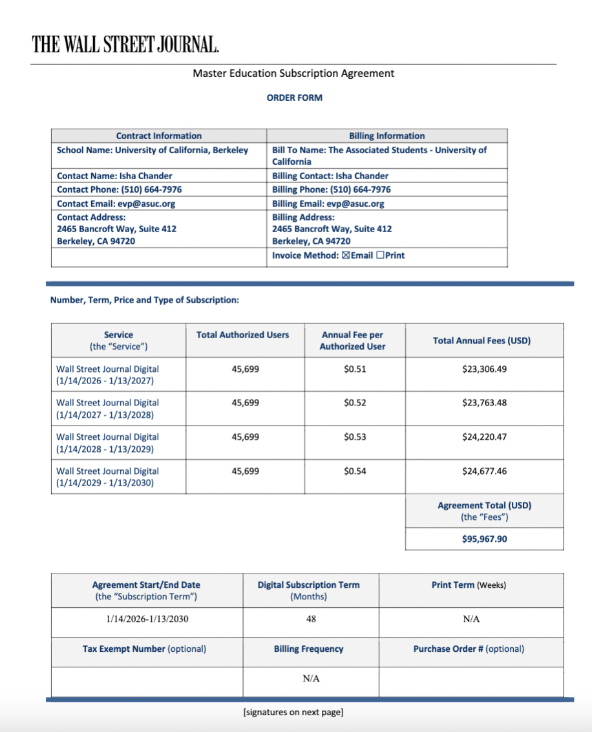

2105 Contracts
ASUC Constitution
SR 19/20-034 Approving a Contract with The Wall Street Journal

